Name: _______________________________ **Course Instructor:** Maryam Omar

Program:______________________________

Roll Num:_____________________________

**Object Oriented Programming**

**Quiz 4**

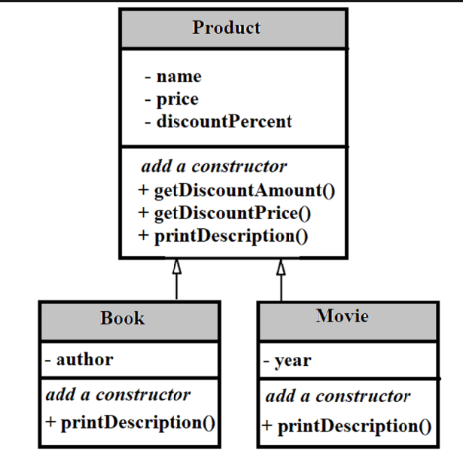

We want to store the information of different products according to the scenario given above.

Create a class named **Product** with three data membersnamed: **name, price and discountPercent**. Create its two subclasses:

1. **Book** with data member to store **author.**
2. **Movie** with data member to store **year**.

Now, store (using parameterized constructors) and print (using printDescription() member function) the information of any two books and movies.

Note:

1. All classes should have a printDescription function.
2. All data members should be initialized and printed only once.